Lab 9: Primary Production Lab
GEOL1551
Name: _____________________________

24th SEPT 2020

Primary Productivity is the rate at which inorganic carbon is utilized by organisms to produce organic compounds. In the surface ocean, this is driven by photosynthesis. The general formula for this is:

6CO2 + 6H2O + sunlight (energy) → C6H12O6 + 6O2 or, more simply: CO2 + H2O + sunlight → CH2O + O2 Where C6H12O6 or CH2O represent organic matter.

Photosynthesis consumes CO2 and produces O2 and the organic compounds (e.g., sugars) that can be used to fuel the metabolism of an autotroph. To grow and reproduce, the sugars are broken down via respiration (the opposite reaction from above) to produce energy. So, respiration consumes O2 and produces CO2 (both autotrophs and heterotrophs respire).

In the oceans, phytoplankton (algae; dominated by diatoms and coccolithophorids – see your textbook for images of these) are responsible for much of the primary productivity, and produce chlorophyll giving them their green color. As you would suspect, they grow where the sunlight occurs (the euphotic zone in the upper 100 to 200 m of the ocean). Diatoms have a skeleton (frustule) made of hydrated silica (SiO2 - nH2O). Thus silicon (Si) is an important nutrient for them. Additionally, primary productivity is dependent on the nutrients phosphate (PO4⁻³) and nitrate (NO3⁻). Every 106 atoms of carbon that are incorporated into organic matter requires 16 atoms of nitrogen and 1 atom of phosphorus (C: N:P = 106:16:1). This is called the Redfield ratio. It is important because if the supply of one of the nutrients is exhausted, then primary productivity stops.

When algae grow, they consume the nutrients as well as CO2, and produce O2. When algae die and sink through the water column, the organic matter is consumed by bacteria which release the nutrients and CO2 back to the water. This is called the Biological Pump (moving CO2 into the deeper water via biological means; for more information see http://earthguide.ucsd.edu/virtualmuseum/climatechange1/06_2.shtml). So, you should be able to predict what the concentration of nutrients and CO2 and O2 should be in the water due to these processes.

The amount of primary productivity can be determined by looking at the amount of chlorophyll in the surface water of the oceans by means of satellite imagery or by direct measurements of the water. Likewise, the nutrients and dissolved gases can be analyzed from water samples taken at different depths through the water column during oceanographic cruises.

With these facts in your knowledge tool belt, answer the following question.
Part I.

Visit: https://earthobservatory.nasa.gov/global-maps/MY1DMM_CHLORA

4 points each
Fig 1: Chlorophyll Map
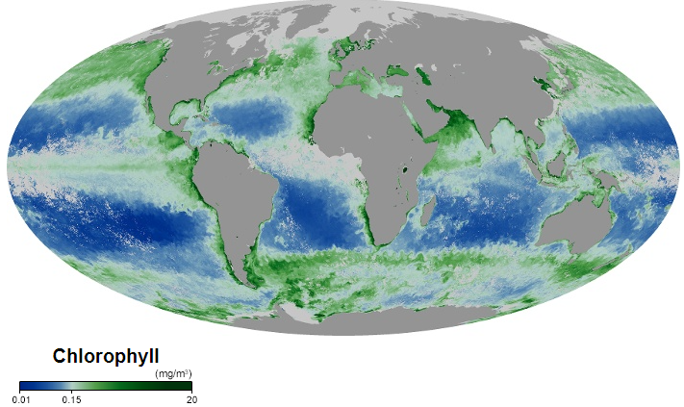

- What does this map show (give the units).

It presents chlorophyll map showing milligrams of chlorophyll per cubic meter of seawater in each month. The units are mg/m³
- In general, where does low chlorophyll occur and what does that mean for the concentration of phytoplankton?

Low chlorophyll occur in places showing blue color. Places with low chlorophyll amounts indicates a very low numbers of phytoplankton concentration and are colored blue in the map.

- What is the relationship between the distribution chlorophyll and surface water temperature (see Select and Compare on the right side of the webpage)?

In places whereby the ocean currents causes upwelling i.e. places where ocean currents bring cold water to the surface like around the equator and along the shores of continents. Sea surface temperatures are cooler in these places hence, chlorophyll concentrations are higher. The relationship is evident in fig 2 below, where there is high chlorophyll concentrations is marked green and one can observe that it is around the equator and along the shores of continents.
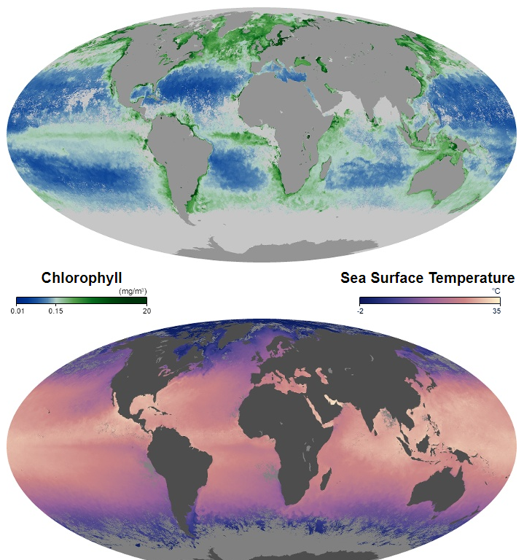
Fig 2: relationship between the distribution chlorophyll and surface water temperature

4. Why does this relationship exist?

In places whereby the ocean currents causes upwelling i.e. places where ocean currents bring cold water to the surface like around the equator and along the shores of continents. Sea surface temperatures are cooler in these places hence, chlorophyll concentrations are higher. The rising and upwelling waters brings nutrients to the sea surface hence the reason why chlorophyll concentration is higher.

5. Why is there high chlorophyll near the coasts?
Upwelling of waters occurs near the coasts, the upwelling waters bring cooler water to the sea surface and in the process, and it curries iron and other nutrients from ocean floor with them to the sea surface. Cold coastal upwelling and subsequent chlorophyll growth is evident along the coastal regions.

Part II. Photosynthesis Exercise
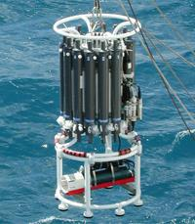
The data below, in Table 1, are the kind of data that would be derived by lowering water sampling bottles (Nisken bottles) through the water column, and remotely triggering their closure at certain depths. These bottles are typically mounted on a “rosette” (https://www.mbari.org/ctd-rosette/), and a CTD is also used to measure the conductivity (salinity), temperature and depth. The samples are then brought back to the ship and analyzed for the constituents shown, which are important for understanding biological productivity.

A rosette consisting of Nisken bottles and a CTD.

- (20 pts.) On the graph paper provided to you plot the data from Table 1 (below):

(a) O2 versus depth (use open circles),

(b) PO4³⁻ versus depth (use X's),

(c) SiO2 versus depth (use open triangles).

Note that when you have plotted (a) it is easy to plot (b) and (c) by matching depths.

Connect the oxygen points with a solid line, the phosphate points with a dashed line, and the silica points with a dotted line.

Plot depth on the vertical axis (increasing from top to bottom) and the concentrations on the horizontal axis (increasing from left to right).

You will use 3 different scales for the three different concentrations. The phosphate curve that you will get shows what oceanographers call a nutrient profile.

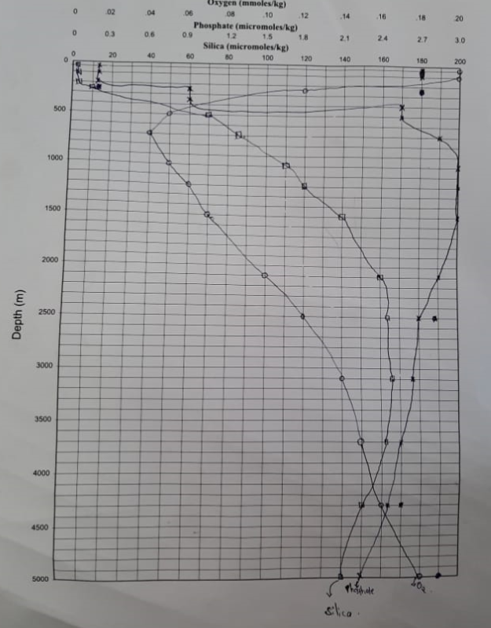
Table 1. Measurements of dissolved gases and nutrients in seawater as a function of depth.

Depth | Oxygen | Phosphate | Silica | TCO2
meters | mmoles/kg | micromoles/kg | micromoles/kg | mmoles/kg
20 | 0.203 | 0.18 | 1.8 | NA
49 | 0.204 | 0.18 | 1.8 | 1.946
99 | 0.209 | 0.18 | 1.6 | 1.973
149 | 0.205 | 0.21 | 1.8 | 2.041
248 | 0.169 | 0.85 | 10.3 | 2.093
544 | 0.053 | 2.61 | 71.7 | 2.303
742 | 0.044 | 2.83 | 86.8 | 2.299
988 | 0.05 | 2.88 | 107.8 | 2.331
1185 | 0.058 | 2.9 | 121.6 | 2.357
1534 | 0.073 | 2.9 | 139.2 | 2.365
2126 | 0.102 | 2.78 | 156.4 | 2.353
2530 | 0.117 | 2.7 | 162.2 | 2.366
3130 | 0.135 | 2.61 | 164.4 | 2.375
3735 | 0.148 | 2.48 | 162.5 | 2.341
4385 | 0.157 | 2.44 | 152.8 | 2.323
4953 | 0.182 | 2.33 | 136.9 | 2.411

Using your plot and the following simplified representation of the photosynthesis reaction (top line shows raw materials and bottom line shows products) answer the questions below.

- Remember that the reverse of the photosynthesis reaction is respiration or decay (top line shows reactants and bottom line shows products). Note that phosphorous (P) in the form of phosphate (PO4⁻³), and nitrogen in the form of nitrate (NO3⁻) are very important nutrients for photosynthesis.

- CO₂ (g) + 122 H₂O (l) + 16 NO₃⁻ (aq) + PO₄³⁻(aq) + 19 H⁺(aq) = (CH₂O)₁₀₆(NH₃)₁₆H₃PO₄(s) + 138 O₂(g)

Or more simply:

Photosynthesis reaction: 6CO2 + 6H2O + sunlight (energy) + nutrients → C6H12O6 + 6O2
Plant decay (or respiration) is the reverse: C6H12O6 + 6O2 → 6CO2 + 6H2O + nutrients

- (6 pts.) Starting at the sea surface (0 meters depth) and working down into deeper water, at what depth do you see the concentrations of oxygen, phosphate and silica start to change?

The concentration of oxygen started decreasing at around 250 meters depth all the way to around 1530 meters depth. It then started to “slightly” increase at around 2000 meters depth all the way to 5000 meters depth.
The concentration of phosphate started increasing at around 250 meters depth all the way to around 2500 meters depth where the concentration started to “slightly” drop all the way to 5000 meters depth.
Silica concentration is different, it is increasing with an increase in water depth. Where significant increase in Silica concentration is observed is around 250 meters depth and then from there, a drastic increase in silica concentration is observed with an increase in water depth.

- (6 pts.) Using the above reactions as guides, which process (either photosynthesis or respiration) could cause phosphate and silica in the water column to increase and oxygen to decrease?

Photosynthesis reaction: 6CO2 + 6H2O + sunlight (energy) + nutrients → C6H12O6 + 6O2
Plant decay (or respiration) is the reverse: C6H12O6 + 6O2 → 6CO2 + 6H2O + nutrients

Respiration could be causing phosphate and silica in the water column to increase and oxygen to decrease. In respiration process, oxygen is being used to break down organic matter resulting into more nutrients. Respiration exceeds photosynthesis with increasing water depths that is why there is more phosphate and silica concentration than oxygen concentration as water depths increases.

- (6 pts.) Based on your answers to “a” and “b” and your nutrient chart, in what portion of the ocean (give the range of depths) is photosynthesis the dominant process in the water column?

Photosynthesis is dominant at shallow water levels i.e. the water level depths from 0 to around 150 meters, evident by the concentration of oxygen levels exceeding the concentration of the two nutrients (phosphate and silica.) This shows that photosynthesis dominates at the depths (0 to 150 meters).

- .(6 pts.) In what portion of the ocean (give range of depths) is respiration and decay the dominant processes in the water column?

Respiration is dominant at deep water levels from around 250 meters all the way to 5000 meters. The dominancy of Respiration at deep water levels is evident by the fact that. In respiration process, oxygen is being used to break down organic matter resulting into more nutrients. Respiration exceeds photosynthesis with increasing water depths that is why there is more phosphate and silica concentration than oxygen concentration as water depths increases.

- (6 pts.) Study the reaction for photosynthesis above and note the position of CO2 – meaning, is it a product of photosynthesis or is it consumed by photosynthesis?) What effect should the downward variation from photosynthesis-dominated to respiration-dominated environments have on the CO₂ concentrations as you go deeper in the water column?

Photosynthesis reaction: 6CO2 + 6H2O + sunlight (energy) + nutrients → C6H12O6 + 6O2

From the photosynthesis reaction above, positioning of CO2 shows that it is being consumed by photosynthesis hence it is a reactant not a product. At shallow water levels where photosynthesis exceeds respiration hence dominating, CO2 concentration levels are extremely low since CO2 is being consumed and the end product is oxygen.

Plant decay (or respiration) is the reverse: C6H12O6 + 6O2 → 6CO2 + 6H2O + nutrients

From respiration reaction above, we can see that one of the end product apart from the nutrients is CO2 meaning that in respiration process, CO2 is being released. At deep water levels the concentration of CO2 starts increasing since it is at this water levels that respiration process begin to exceed photosynthesis. The more the respiration process dominates, the more CO2 is being released.

- (6 pts.) Now look at the column of CO₂ concentrations given in Table 1. Is your predicted effect on CO₂ concentration observed in the table of concentrations? Explain what happens to CO2 concentrations from shallow water to deeper water.

Yes my predicted effect on CO₂ concentration is observed in the table of concentrations. At shallow waters, the concentrations levels of CO2 is extremely low and at deeper water levels the concentration levels of CO2 is higher. The concentrations levels of CO2 increases as you go from shallow water levels (photosynthesis dominated levels) to deeper water levels (respiration dominated levels).

- (8 pts.) Based on the depth to which photosynthesis dominates (given in answer c above), to what depth in the ocean do you think significant amounts of sunlight penetrate? [Remember, sunlight is necessary for photosynthesis to occur!]

Significant amount of sunlight penetration occurs to about 200 meters depth of sea water. This is evident by the fact that we have photosynthesis processes dominating from 0 water levels to the depths around 200m. Photosynthesis is dominant at shallow water levels i.e. the water level depths from 0 to around 200 meters, evident by the concentration of oxygen levels exceeding the concentration of the two nutrients (phosphate and silica.) This shows that photosynthesis dominates at the depths (0 to 200meters). Beyond 200 meters, there is extremely minimum almost insignificant amount of sunlight penetration and that is where respiration starts exceeding photosynthesis evident by the concentration levels of the nutrients exceeding oxygen levels.

- (8 pts.) Study the photosynthesis reaction and explain why phosphate concentrations are so low in the surface waters?

Photosynthesis reaction: 6CO2 + 6H2O + sunlight (energy) + nutrients → C6H12O6 + 6O2
At surface waters, the most dominant process is photosynthesis. Photosynthesis uses CO2, sunlight and nutrients to generate energy and oxygen. Phosphate is one of the nutrients being used during photosynthesis process to generate energy and oxygen. Since phosphate is being consumed in photosynthesis process which occur at shallow water levels, then the concentrations of phosphates will automatically get low at surface waters.

- (8 pts.) Look at your nutrient chart. Does silica show a nutrient profile? (Does it follow a similar pattern as phosphorus, for example?) If so, why do you think this is the case? What organisms might be using silica as a nutrient?
The concentration of phosphate started increasing at around 250 meters depth all the way to around 2500 meters depth where the concentration started to “slightly” drop all the way to 5000 meters depth.
Silica concentration is different, it is increasing with an increase in water depth. Where significant increase in Silica concentration is observed is around 250 meters depth and then from there, a drastic increase in silica concentration is observed with an increase in water depth.
It can be concluded that Silica shows the most significant nutrient profile, the concentrations are lower at the water surface (shallow waters) perhaps due to biological uptake of silica nutrients by sea creatures who need silicon to develop their skeletons. Most of these marine creatures such as phytoplankton and surface water fish which are in abundant live near the ocean's surfaces and uses most of silicon nutrient to develop their skeleton

